Nested Decisions

Look at this code:
raining = input("Is it raining? yes/no: ")
if raining == "yes":
windy = input("Is it windy? yes/no: ")
if windy == "yes":
print("Wear a coat.")
else:
print("Take an umbrella.")
else:
print("No rain gear needed.")

What do you think this code will display?
Click or tap here to enter text.

Run the code. Compare the result with your prediction:
Click or tap here to enter text.

Let’s investigate! Answer the questions below:
- Why is the windy question skipped when the first answer is no?
Click or tap here to enter text.

- If you answer yes to raining and no to windy, what message appears?
Click or tap here to enter text.

- Which if does the inner else belong to, and how does indentation show this?
Click or tap here to enter text.

- What route is taken for an unexpected first answer such as maybe, and why?
Click or tap here to enter text.

Nested Decisions

Look at this code:
raining = input("Is it raining? yes/no: ")
if raining == "yes":
windy = input("Is it windy? yes/no: ")
if windy == "yes":
print("Wear a coat.")
else:
print("Take an umbrella.")
else:
print("No rain gear needed.")

Use the code above to help you. After completing each challenge below, run your program to test that it works correctly. Save each completed challenge program in a new file.

Programming Challenges

Challenge 1
Change only the inner yes route so yes followed by yes displays "Wear a waterproof coat."
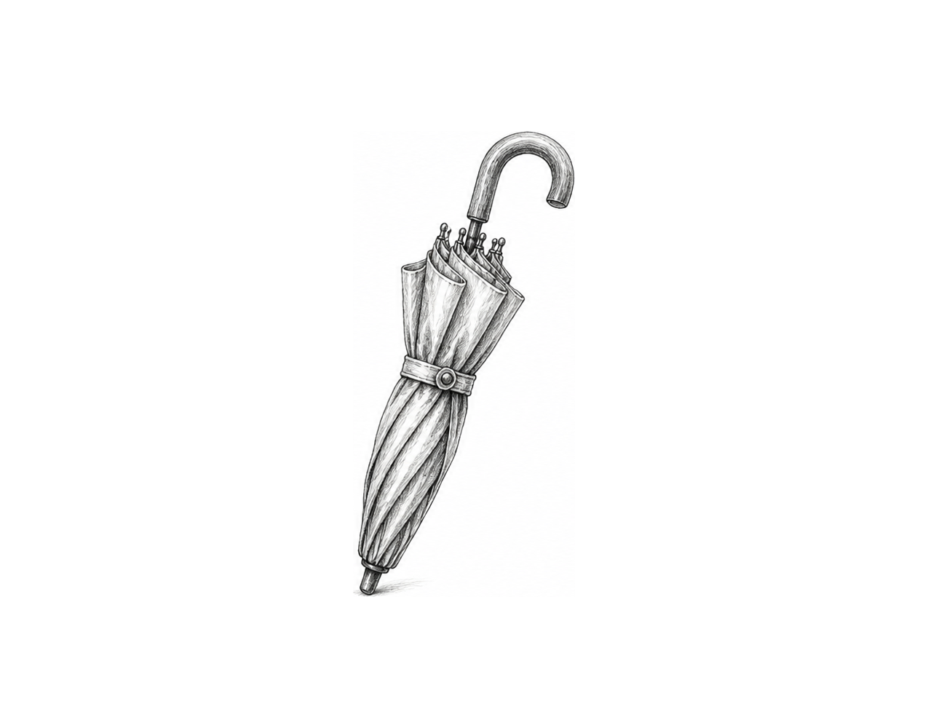

Challenge 2
Extend the dry-weather route. If raining is no, ask whether it is sunny; display "Take sunglasses." for yes and "No weather gear needed." for no.

Challenge 3
Build a library-access checker. Ask whether the visitor has a card. Only card holders are asked whether a book is overdue. Display one clear message for all three possible routes.

Nested Decisions

Fix the code!

This code has errors! Look closely at the code to find the problems:

raining = input("Is it raining? yes/no: ")
if raining == "yes":
windy = input("Is it windy? yes/no: ")
if windy == "yes"
print("Wear a coat.")
else:
print("Take an umbrella.")

Rewrite the whole program in the box below with fixes to the errors.
Click or tap here to enter text.

After you are confident that you fixed all the errors, copy the code from the box and run it.

Did it work correctly on your first try? Did you find all the errors?
Click or tap here to enter text.

